COS225 Assignment #3 Name ________________________
Due: Friday 2/16/18
Late: Friday 2/23/18
Readings: Chapter 15

Assignments should be submitted to Blackboard by the due Note: Read directions on Assg #1 regarding submission requirements. They will no longer be repeated.

Create a Word or RTF or PDF document (no other formats please) with answers to Part I questions and the screen shots of program output.

Part I. (20 pts) Enter answers into your document; please do not include this document.

1. An ______________ would be written to process code when a button is clicked.

a. event source object b. event object c. event handler object

2. When a button is clicked, the _____________ event type occurs.

a. ActionEvent b. MouseEvent c. KeyEvent d. none of the above

3. Which statement is not true about inner classes?

a. An inner class is defined within the scope of another class.
b. An inner class may access class-level variables of the enclosing class.
c. An inner class is hidden from view by the client of the enclosing class.
d. Variables declared within the inner class may be accessed by the enclosing class.

4. The following code is an example of ______________.

btnNext.setOnAction (new EventHandler<ActionEvent>( ) {
public void handle(ActionEvent e) {System.out.println "Hello"); } });

a. lambda expression b. anonymous inner class
c. explicit inner class d. none of the above

5. The ____________ method is used to read the return the content of text within a TextField control.

a. getText b. getString c. setText d. setEditable

6. Use the _______________ animation to make a circle move around the outline of a polygon.

a. PathTransition b. FadeTransition c. Timeline

7. In order to move a ball downward by 5 pixels in its pane, the ______________.

a. x direction is increased by 5 b. x direction is decreased by 5
c. y direction is increased by 5 d. y direction is decreased by 5

8. Code that implements the EventHandler<ActionEvent> interface must implement the ___ method.

a. event b. handle c. lambda d. setOnAction
Answer questions about the code below.

public class Question9 extends Application{
private int radius = 30; // circle radius
private int x = 100; // start x coordinate
private int y = 100; // start y coordinate

public void start (Stage primaryStage)
{ BorderPane bPane = new BorderPane( );
Button btnNext = new Button ("Next");
bPane.setTop(btnNext);
bPane.setPadding(new Insets(10,10,50,10));
Scene scene = new Scene (bPane, 500, 500);
primaryStage.setScene(scene);
primaryStage.show( );

btnNext.setOnAction(new EventHandler<ActionEvent>( ) {
@Override
public void handle(ActionEvent e) {
radius += 5; x+= 10; y += 10;
Circle c = new Circle(radius);
bPane.getChildren( ).add(c);
c.setCenterX(x);
c.setCenterY(y);
c.setFill(Color.PURPLE);
}});
} }

9. What is the visual output if the button is clicked ten times?

a. One large purple circle is seen.
b. A purple eggplant shape is seen.
c. Ten non-overlapping circles with increasing radii appear left to right.
d. Ten non-overlapping circles with increasing radii appear top to bottom.

10. Would the code work correctly if the Circle c declaration was moved from the event handler to the top of the start method?

a. Yes b. No
Part II. (80 pts.) Write a JavaFX program to solve the following problem. Two buttons appear at the top side by side. When the Park button is clicked, a small car drives from the right side onto the road and parks in the garage. The garage can hold five cars. When the Unpark button is clicked, the bottom car drops down from the garage, drives left, drives up, and drives right off the screen. A car is designed, minimally as rectangle on two circular wheels. Each car should be a random color. Include your name as stage title. You do not need to do a lot of error checking unless you wish; assume the user clicks Park five times and then Unpark five times. (Refer to demo in lecture.)
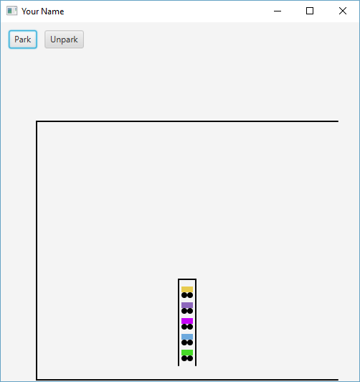
Display after parking five cars:

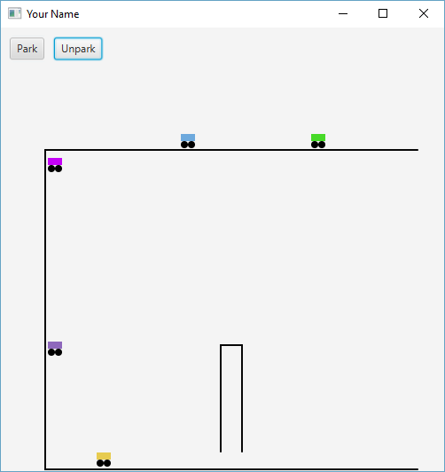
Display showing unparking:

Click the Blackboard Assignment #3 link and attach your document of short answers two screen shots (one after parking 5 cars and one unparking 5 cars) and .jar file. The grader will run your program and critique the code. Usual rules on grading and turnaround time apply and will not be repeated.

